Update for key stakeholders
16 December 2022

Vaccination
As at 11 December, we had carried out a total of 124,451 COVID vaccinations and 145,576 flu vaccinations as part of the winter 22-23 vaccination programme. Vaccination figures across the whole of the NHS Highland area are:
 | Over 65s % complete | Health & social care staff % complete | 5-65s at risk % complete
COVID | 87.6 | 48.8 | 56.7
Flu | 81.3 | 46.9 | 51.0

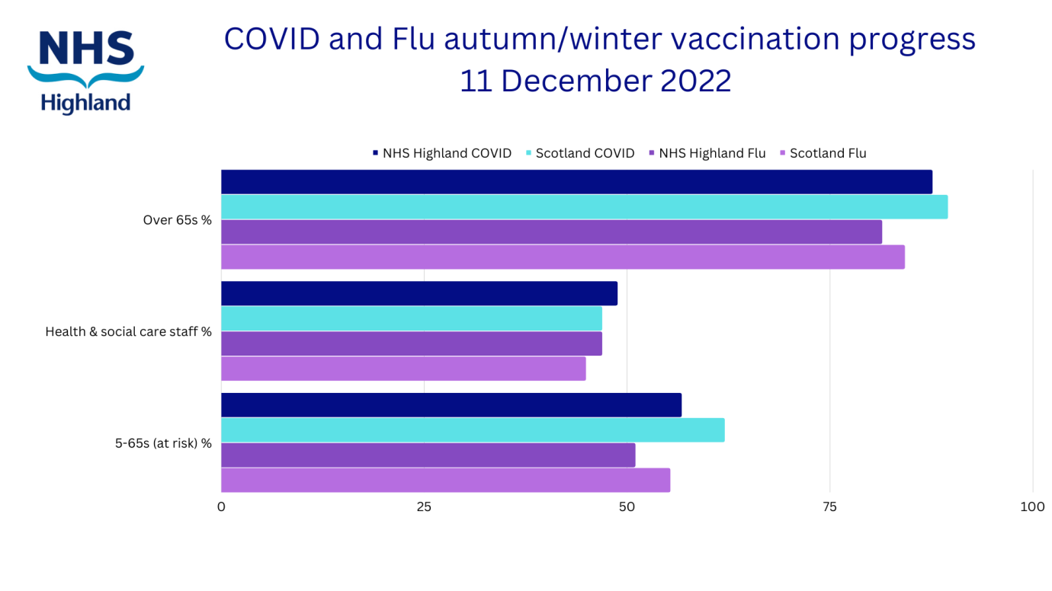
Appointment of Executive Nurse Director

Following the retiral of Heidi May in October 2022, we held a competitive external recruitment process overseen by the Chief Executive, the Chair and the Deputy Chief Nursing Officer from Scottish Government.

We are delighted to confirm that Louise Bussell, currently Interim Chief Officer for the Highland HSCP, has been appointed to the role of Executive Nurse Director with effect from 1 February 2023. We congratulate Louise on her appointment and look forward to working with her in this exciting new role, leading the Nursing, Midwifery and Allied Health Professions through an exciting and challenging period of transformation and change within Board and the wider NHS Scotland. Louise will be a member of the Executive team and also an Executive member of the NHS Highland Board.

Louise has been with NHS Highland since July 2020, when she joined us as Head of Mental Health and Learning Disabilities, before taking up the Interim Chief Officer post in November 2020. Prior to joining NHS Highland, Louise gained her Registered Mental Health Nurse qualification at the University of Derby before progressing her career across NHS Trusts in Nottinghamshire, Derbyshire and Lincolnshire and her experience has spanned across Acute and Community Mental Health, Learning Disability, specialist services and secure hospital settings. She carried out the role of Matron for a number of years before moving on to be Associate Director of Nursing, Quality and Patient Experience, as well as taking on General Manager roles and latterly a Deputy Director role for Forensic Services, before her move to Highland.

Kate Patience-Quate will continue to cover the role on an interim basis until 31 January 2023 and then will continue in her post of Deputy Nurse Director. We would like to thank Kate for her ongoing commitment and contributions in the interim post which have been much appreciated.

Board Chair, Professor Boyd Robertson, commented "Louise has proven her leadership skills in her current role as Chief Officer and I am confident that she will deploy that skillset and use her wide-ranging experience in varied healthcare settings to good effect as Executive Nurse Director. She will be ably supported in the new role by Kate who has intimate knowledge of NHS Highland and of the area we serve."

An internal process to appoint a new Interim Chief Officer on a secondment basis will take place shortly.

Joint inspection of services for children and young people at risk of harm in Highland

The Care Inspectorate has published their report into their inspection of services for children and young people at risk of harm in Highland. The Chief Executives of Highland Council and NHS Highland, the Commander for Police Scotland, Highlands and Islands, and the Chair of the Child Protection Committee, have welcomed the Care Inspectorate’s findings. Collectively, they wish to highlight the key strengths in relation to the partnerships prompt and effective responses when children were at risk of harm.

The Care Inspectorate also found that the partnerships response remained a strength throughout the pandemic. The Care Inspectorate noted that the partnerships were robustly sharing information and working together in making decisions that ultimately ensured that children at risk of harm were safe.

The inspectors also identified a number of key areas for improvement, which are fully accepted to ensure continuous improvement of services across Highland. Improvements began before the inspection. The findings of the inspection will enable the partnership to continue its journey relentlessly focusing on the best possible outcomes for children and families across the Highlands.

National Treatment Centre (NTC) update
The National Treatment Centre Highland (NTC-H) is one of a national network of 10 treatment centres funded by the Scottish Government aiming to provide additional acute, diagnostic and treatment capacity within Scotland. The NTC-H will provide Orthopaedic and Ophthalmology activity.

Situated at the Inverness Campus, building work on the centre is scheduled to be substantially complete in December 2022. There will then be a period of residual commissioning activity and snagging before operational commissioning, which will take about 16 weeks, is complete in April 2023 prior to the centre opening that month.

Recruitment is progressing as part of our Aim Highland recruitment campaign, and we were on course to have 70% of the posts recruited to by the end of November.

A detailed transfer and mobilisation plan has been developed to ensure that all equipping, staff orientation and staff training can be undertaken within the timescale required prior to opening in April 2023

The NTC-H was discussed at our last Board meeting in November – the full paper with further detail can be found on our website.

Caithness Redesign

Following Scottish Government approval of the Initial Agreement in February 2022, the redesign of adult health and social care services in Caithness is continuing at pace. It is following a similar trajectory to Lochaber, with a series of intensive service model workshops for acute (Caithness General) and community (Wick and Thurso Community Hubs) scheduled to run until February, with cross-check events in early March. These will produce a service operational brief for each of the three building projects, allowing the appointment of the respective design teams by end March 2023.

A technical appraisal of shortlisted sites for the Wick Community Hub & Care Village has been undertaken, and we expect a final decision on the chosen site to be made by the Programme Board in January 2023.

A successful test of change for an overnight care service in East Caithness is now complete. This was shown to facilitate discharge, reduce admissions, and provide greater choice in location of end of life care. Construction work to create two step up beds at Pulteney House care home is set to complete in January 2023, which will enable another test of change of the new service model.

Lochaber Redesign

Service Workshops in Lochaber are ongoing with a final cross-check workshop planned for early February 2023. This will mark the culmination of what has been a very intensive process for the staff involved and will allow us to finalise the Clinical Output Specification. This key document will describe the services to be provided in the new Belford Hospital and describe the accommodation required, forming a key part of the brief for the new building. The appointment process for the Principle Supply Chain Partner, who will both design and build the new facility, is underway and expected to complete in March 2023, with design work commencing thereafter.

Skye rural support and urgent care
Portree and Braes Community Trust, in partnership with other organisations, have produced a video explaining the work of the Rural Support Team in north Skye and how urgent care is being delivered in the area. We will be sharing the video online and hope you find it interesting.

Feedback
If you have comments or queries please contact nhshighland.feedback@nhs.scot

